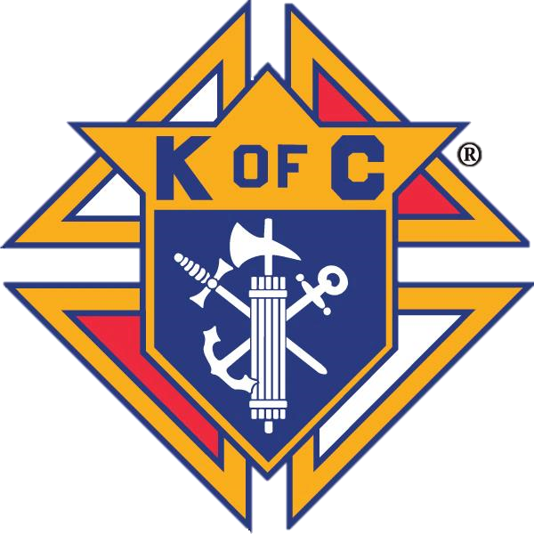

Knights of Columbus Council 4917



**Saturday, March 22, 2025**

**9:00 AM to 2:30 PM**

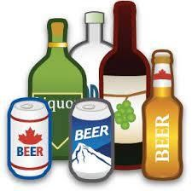

St Joseph Parish Parking Lot, 135 Livingston Avenue, Grimsby

We will be collecting all recyclable

**Beer, Liquor and Wine containers**

Proceeds to support local charities

Thank you for your support!

The Knights of Columbus Council 4917 is a registered charitable organization